1. After the d3.json call add the following map function go get your income and life expectancy.

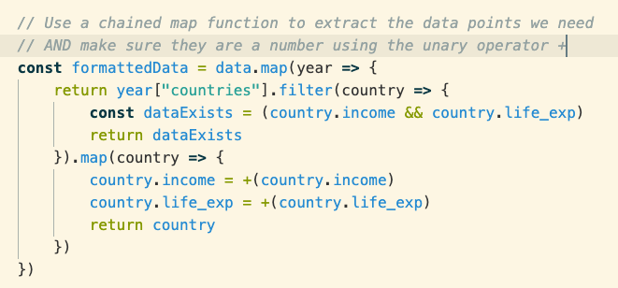

Log your data before and after so you can see the differences.

1. Add an interval function – take a look at the documentation to see what the interval function does then add the following code.

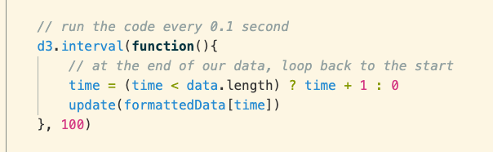

1. Now we will complete our update function – there is a very specific update pattern – don’t be concerned if you don’t get this immediately. Just add the following code to our update function

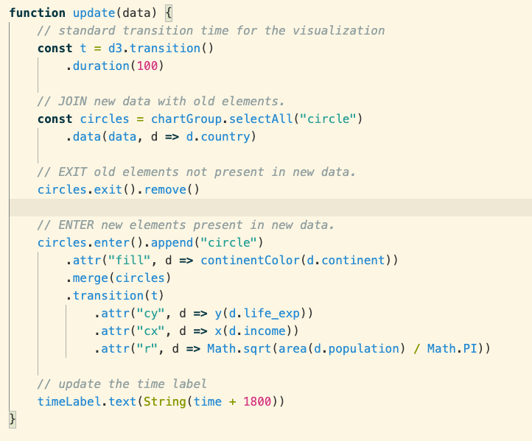

1. Do some research online and add a LEGEND to this chart.